**String Utility**

**Description**

String Utility module has several Java functions which can be used in your application such as repeat, charAt, charCodeAt etc.

These functions can be called in a Java action or a microflow.

You can view the complete list of Java action in the features section.

**Typical Usage Scenario**

If in your application, you need to perform some actions on any string like creating a new string by repeating old string pattern given number of times or finding character in a string at a particular index, etc then you can directly import this module and use these functions.

**PreRequisites**

NA

**Features and limitations**

1. repeat - The repeat function creates a new string by repeating the given string a specified number of times and returns it.
2. charAt - The charAt function returns the character at the specified index in a string.
3. charCodeAt - The charCodeAt function returns an integer between 0 and 65535 representing the UTF-16 code unit at the given index.

**Dependencies**

1. Requires Mendix 9.1.0 or above

**Installation**

1. Download the package from marketplace.
2. Import the module package into your project.
3. Configure security of application by providing access for respective module roles.
4. You may add String Operations page to navigation to view the example (check the screenshot below) or you may use the functions directly present under the Java Actions folder.
5. A screenshot of a computer

   Description automatically generated

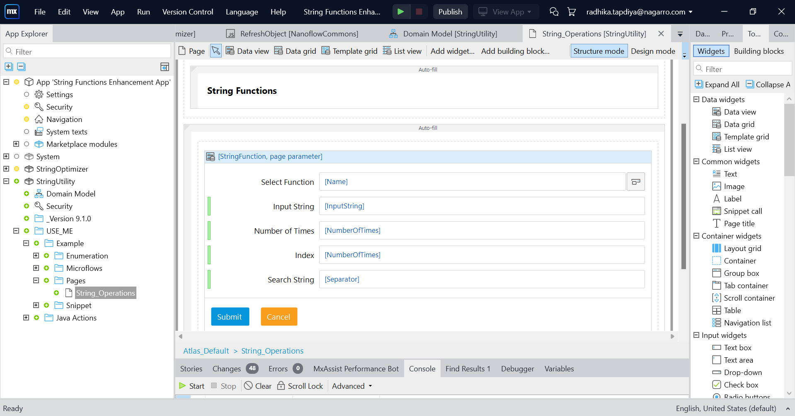

1. Navigate to the String Functions Page
2. Select function from dropdown and provide the inputs in fields then click on submit button.

**Configuration: NA**

**Category: Module**

**Subcategory: All**

**Visibility: Public Marketplace**

**Studio Pro Version: 9.1.0**